G.V.Sai Kiran

18114026

P2

Implement N Queens problem to show all the possible combinations in N x N binary matrix and to display the total number of such combinations at the end, where 1 represents the position of N queens in the N x N matrix and remaining cells are represented by 0.

Sol:

This is achieved by back tracking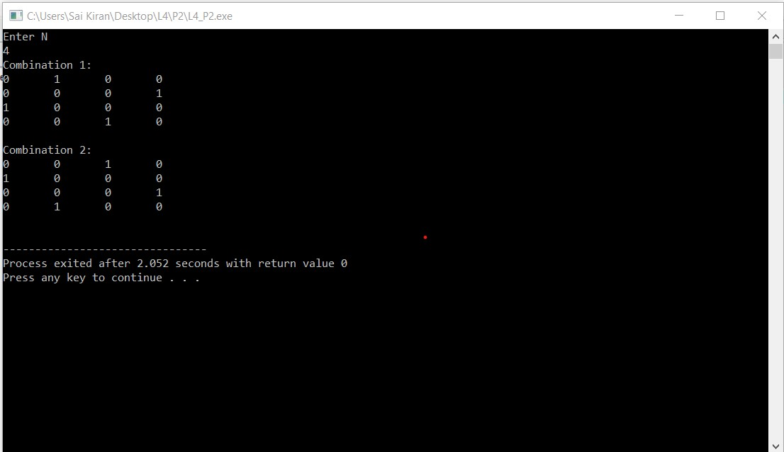P3

Given an integer array having N number of elements, write a C++ program using hash map (using STL) to find the length of the largest subarray from the given input array, where the summation of the elements of the subarray is equal to n. In the output, if any solution exists then print the starting and ending index (with respect to given input array) of the largest subarray and also print its length. Otherwise, print “Not Found”, as described in the following output..

Sol: